{Your school/corporation letterhead}
July 2, 2026
Dear parent/guardian,
The health and wellness of all students within the (name of school or corporation) is a top priority. We want to ensure that our students are up to date with the State of Indiana’s required immunizations to help us provide a healthy environment within the (school/corporation) and for our community.
A review of your child’s immunization record shows they lack one or more immunizations (or an updated record of immunizations) required by the Indiana Department of Health. A list of the Indiana Required and Recommended School Immunizations are shown here:
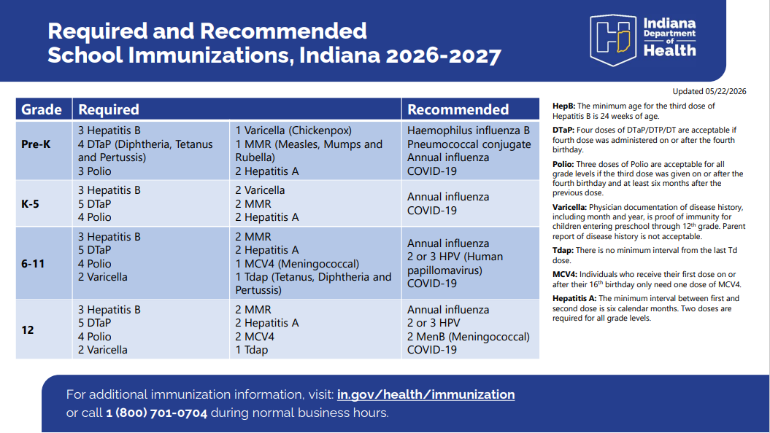
Required and Recommended School Immunizations, Indiana
The attached shows the specific immunizations which are needed for your child. (print a list from CHIRP or create your own to include) If your child has already received these immunizations, please bring the immunization record to the school health office so that we can update our files. The immunization record must include the date (month/day/year) for each dose of vaccine administered. If you are unsure of your child’s status, you may contact your health care provider for immunization records.
If your child has not received these immunizations, please see below for guidance on obtaining the required immunizations per Indiana State Code IC 20-34-3-2:
• Obtain immunizations at your child’s health care provider’s office
• Obtain immunizations at the (your) County Public Health Clinic: (address and phone of your county health department) for an appointment and for payment options
• List any other locations in your community that offer vaccines – for example local pharmacies for those age 12 and older who have health insurance, community clinic (if applicable)
• Provide the school’s health office with a Medical Exemption Form which can be found here Medical Exemption Form for Providers The Medical Exemption Form must be completed and signed by your child’s health care provider. It must state in writing that the child has a medical contraindication to receiving a specific vaccine. Many contraindications to vaccination are not permanent so a medical exemption should be obtained for the student each school year. As a true medical contraindication to immunization is vaccine-specific, a medical exemption must be written for each vaccine that is contraindicated.
• If you have a religious objection to vaccinations, the objection must be in writing, signed by the child’s parent, and delivered to the school. A religious objection must state that the objection to immunization is based on religious grounds. To ensure the continued religious objection status for a student, parents must provide written documentation of the religious objection each school year. There is no state form for a religious objection. Please note that medical exemptions and religious objections must be completed every school year, within 20 days of the start. Failure to comply within the first 20 days of the 2025-2026 school year may result in exclusion proceedings per State Code IC 20-34-3-2.
If you have any questions, please contact your child’s school health office at (insert district/school clinic phone number) for guidance.

Thank you,
School/district nurse name and credentials
Email:
Phone: extension
Fax:

